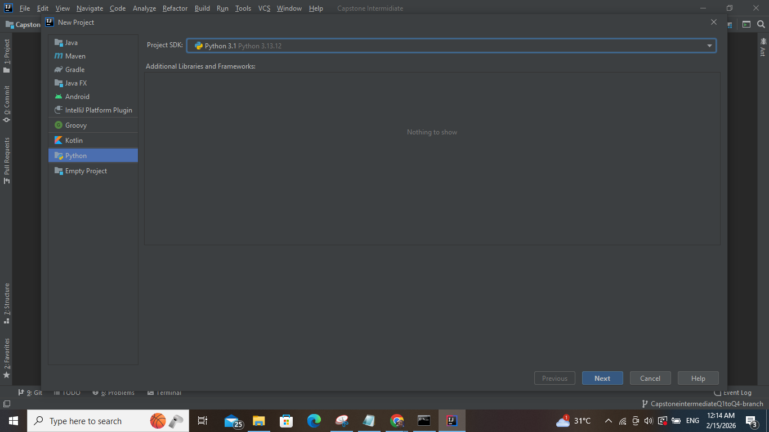

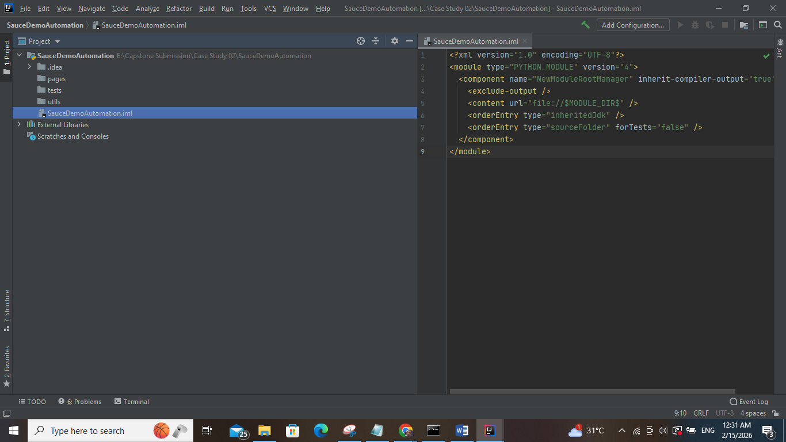

driver_factory.py

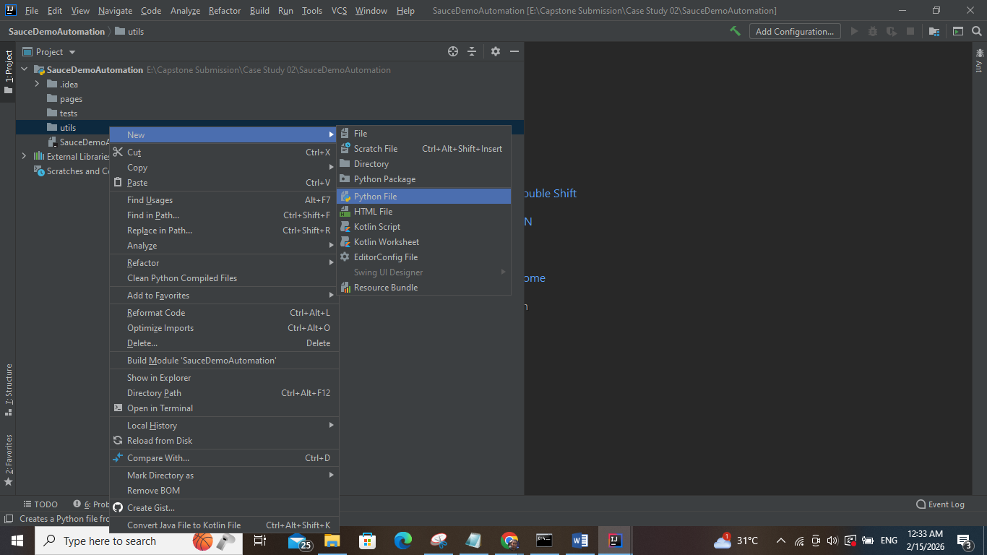

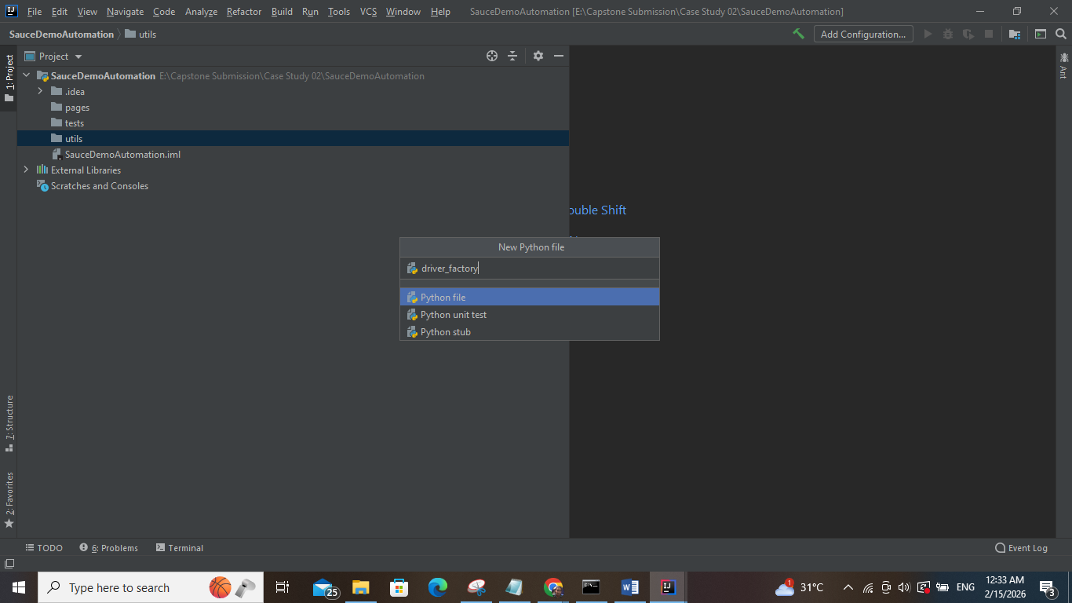

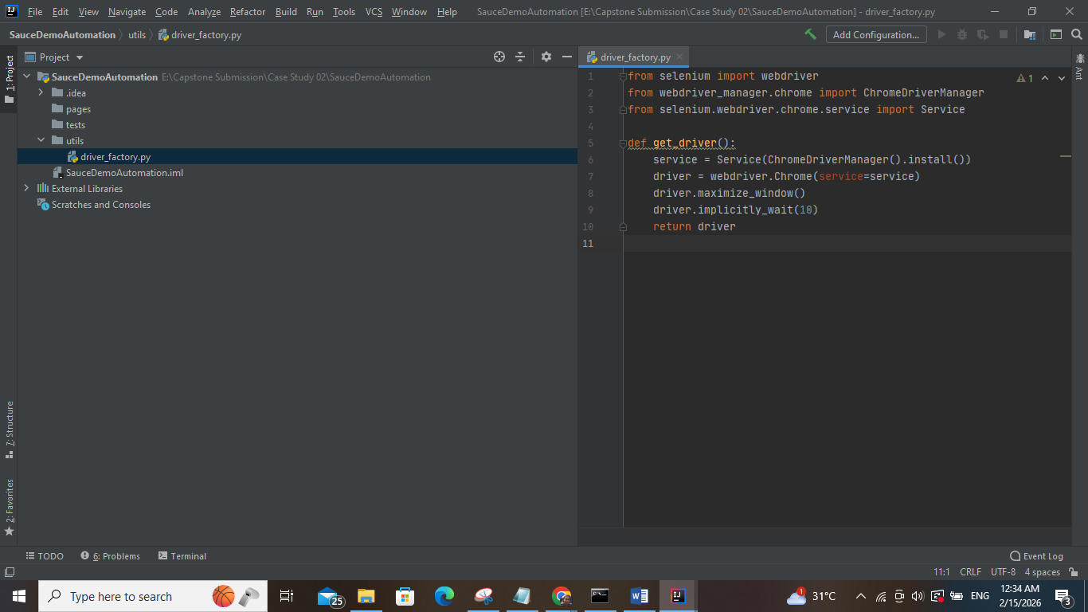

from selenium import webdriver  
from webdriver_manager.chrome import ChromeDriverManager  
from selenium.webdriver.chrome.service import Service  
  
def get_driver():  
 service = Service(ChromeDriverManager().install())  
 driver = webdriver.Chrome(service=service)  
 driver.maximize_window()  
 driver.implicitly_wait(10)  
 return driver

**base_page.py**

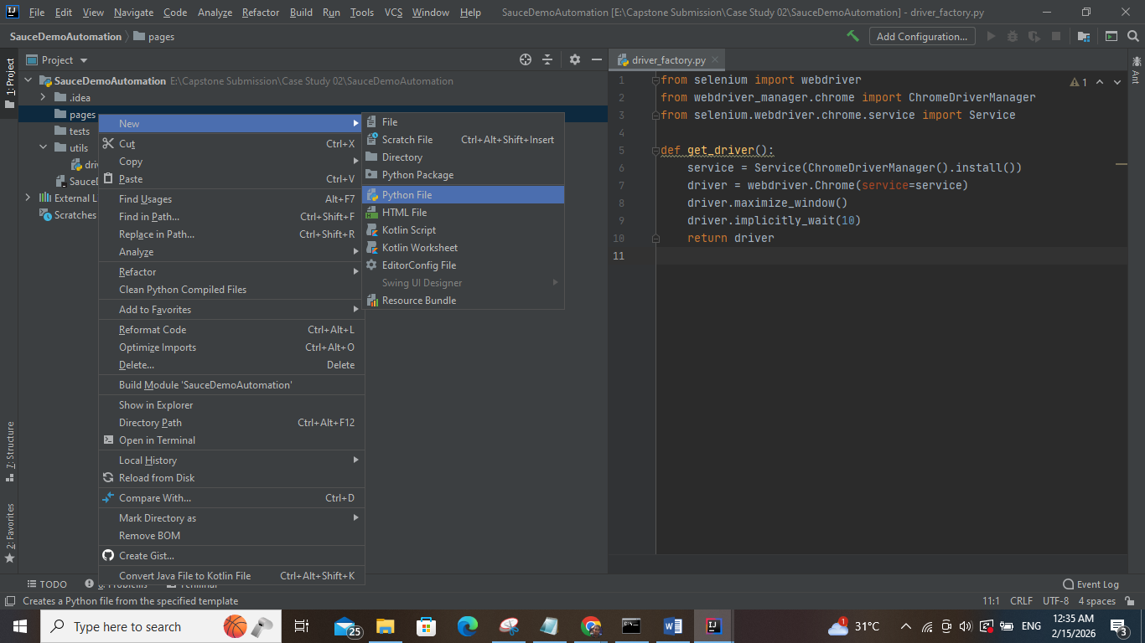

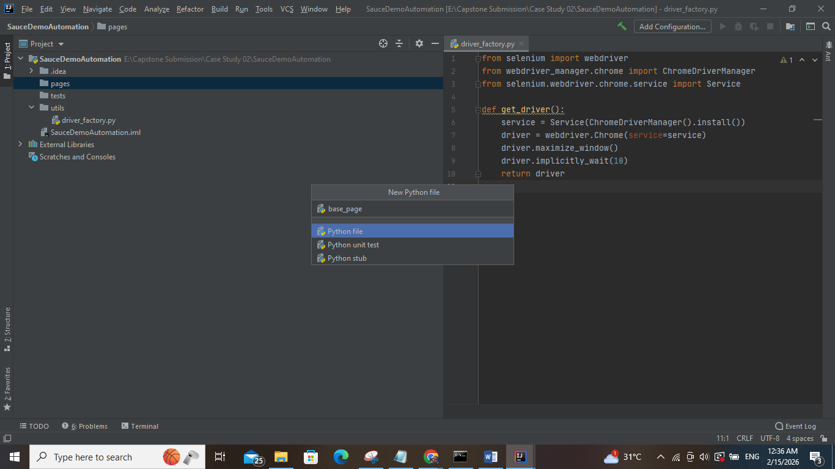

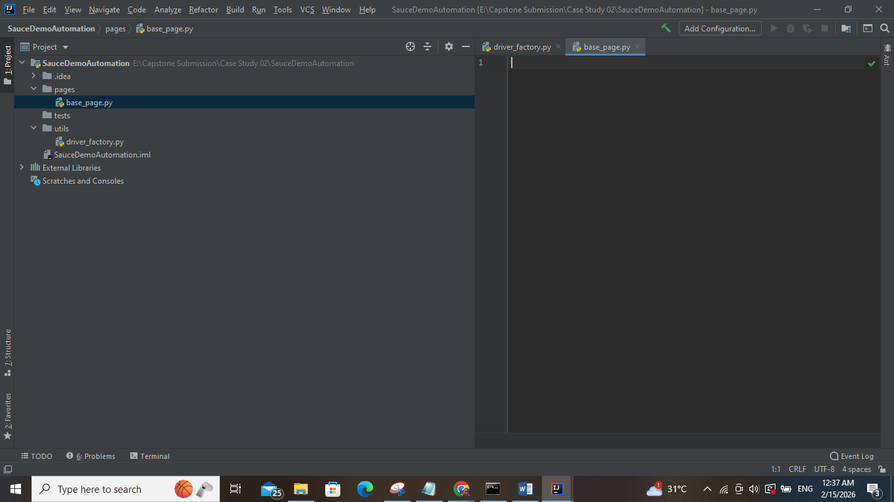

class BasePage:  
 def __init__(self, driver):  
 self.driver = driver  
  
 def click(self, locator):  
 self.driver.find_element(*locator).click()  
  
 def get_text(self, locator):  
 return self.driver.find_element(*locator).text  
  
 def is_displayed(self, locator):  
 return self.driver.find_element(*locator).is_displayed()

### login_page.py

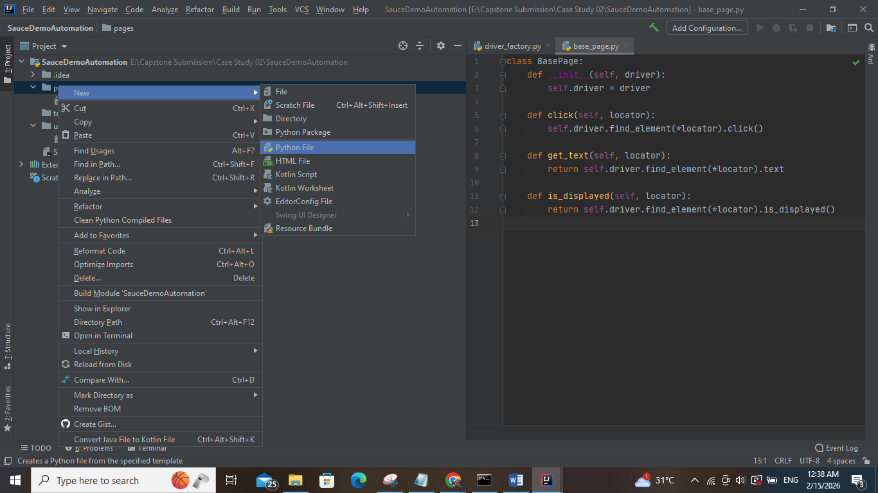

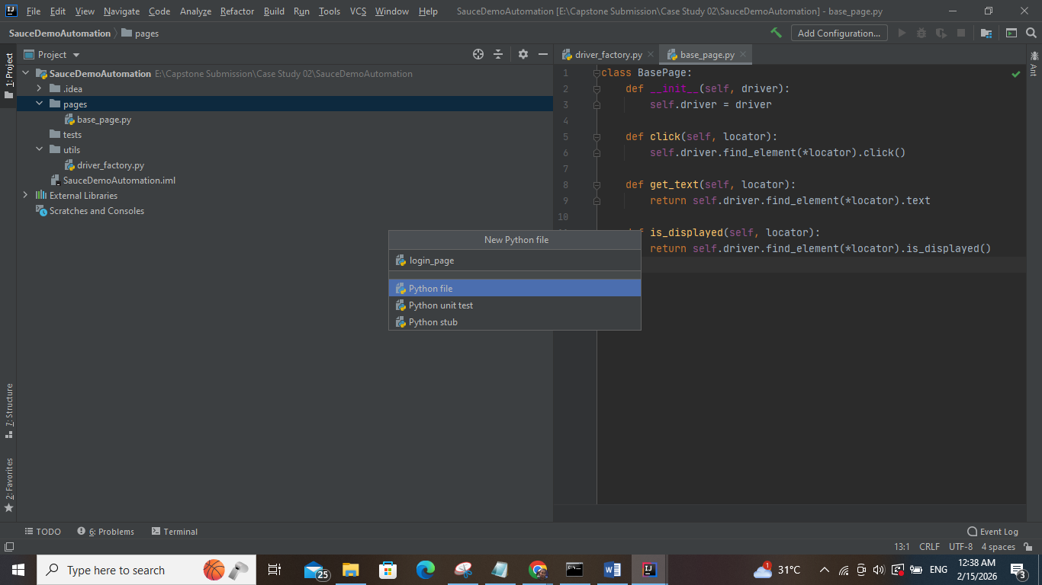

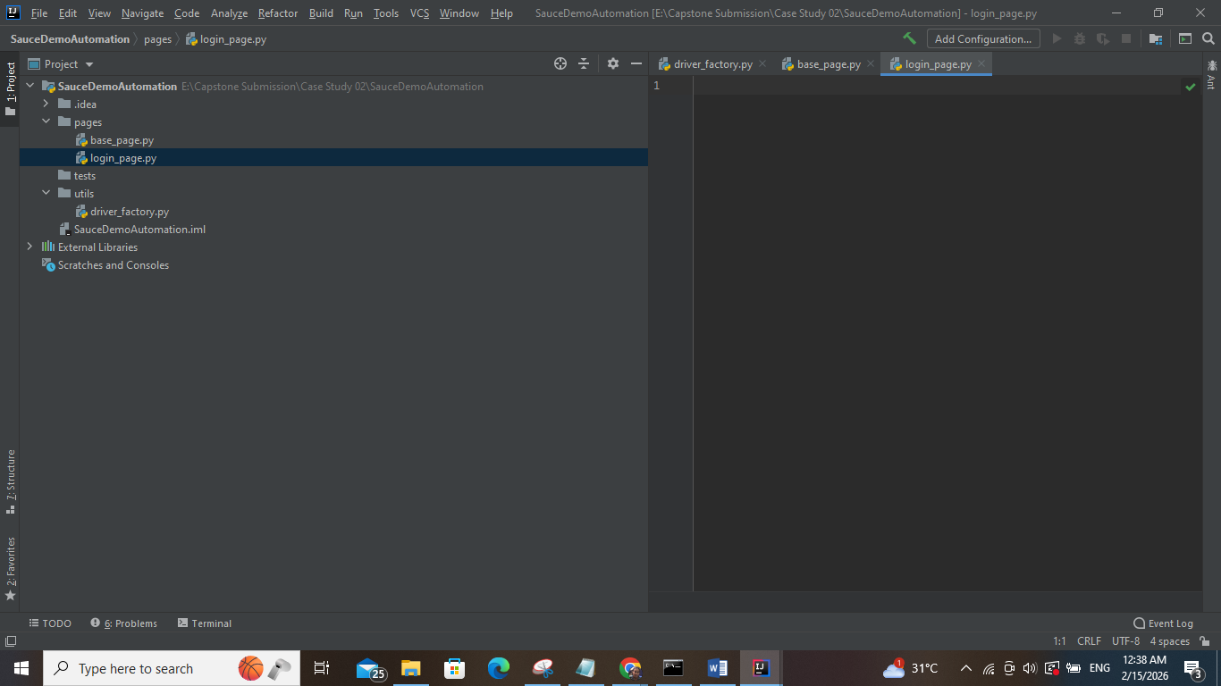

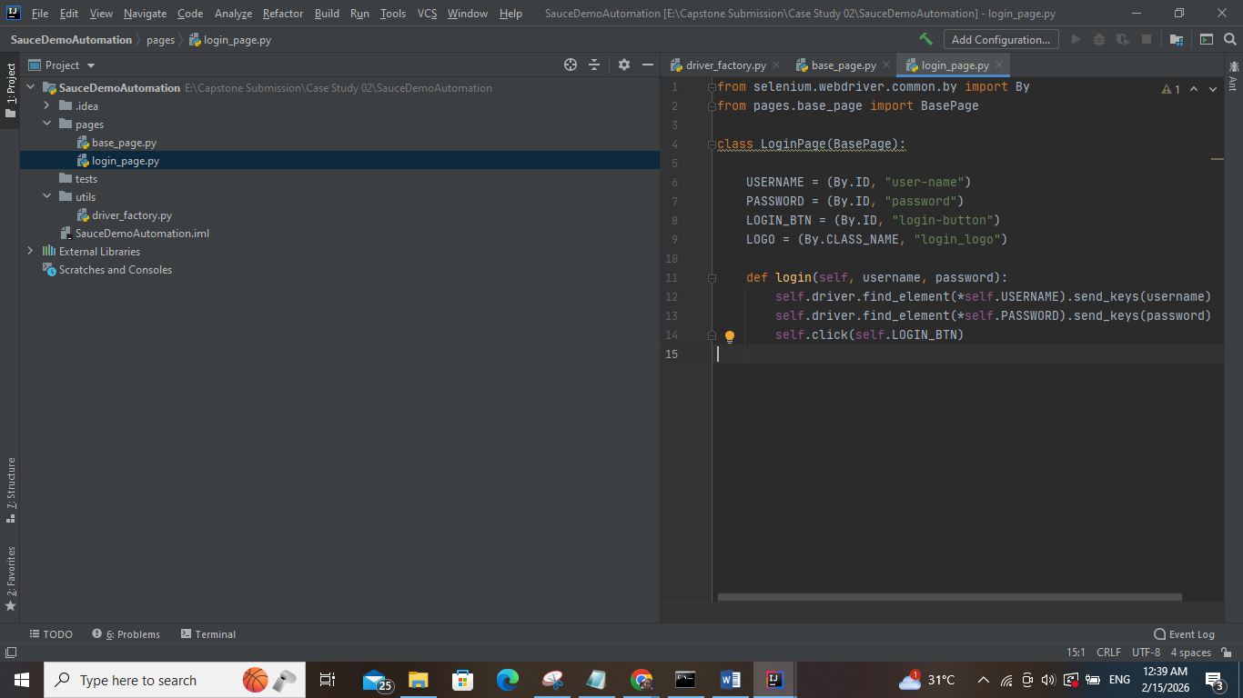

from selenium.webdriver.common.by import By  
from pages.base_page import BasePage  
  
class LoginPage(BasePage):  
  
 USERNAME = (By.ID, "user-name")  
 PASSWORD = (By.ID, "password")  
 LOGIN_BTN = (By.ID, "login-button")  
 LOGO = (By.CLASS_NAME, "login_logo")  
  
 def login(self, username, password):  
 self.driver.find_element(*self.USERNAME).send_keys(username)  
 self.driver.find_element(*self.PASSWORD).send_keys(password)  
 self.click(self.LOGIN_BTN)

### inventory_page.py

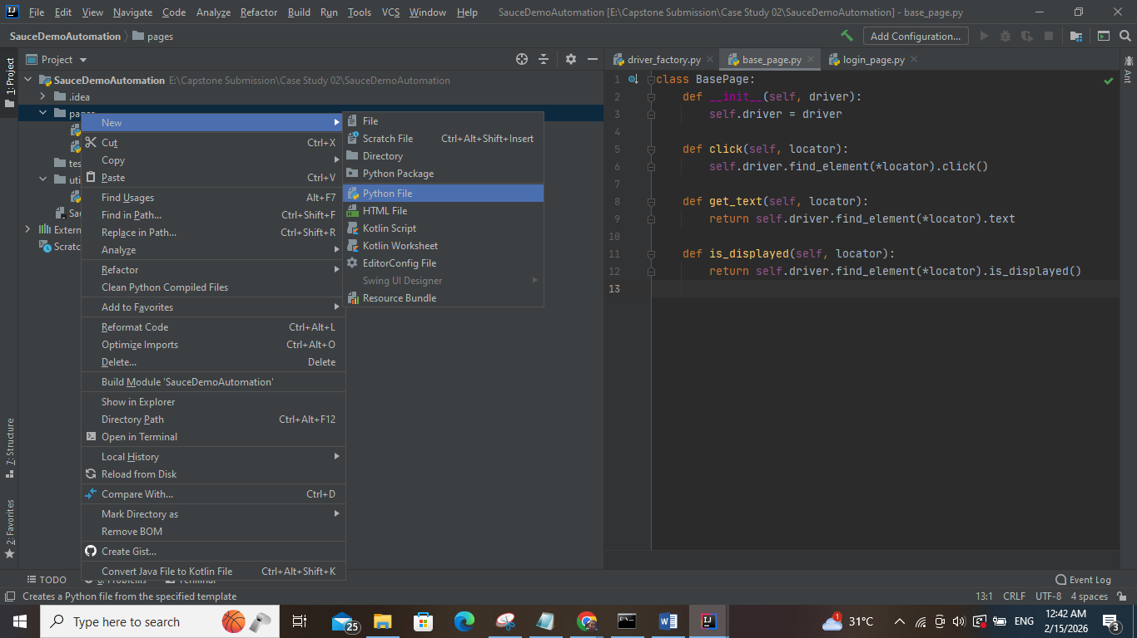

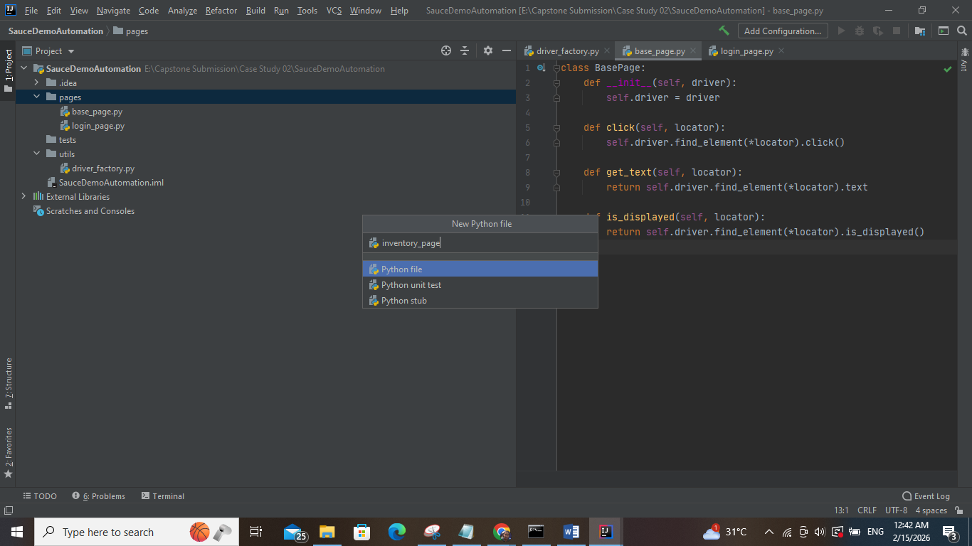

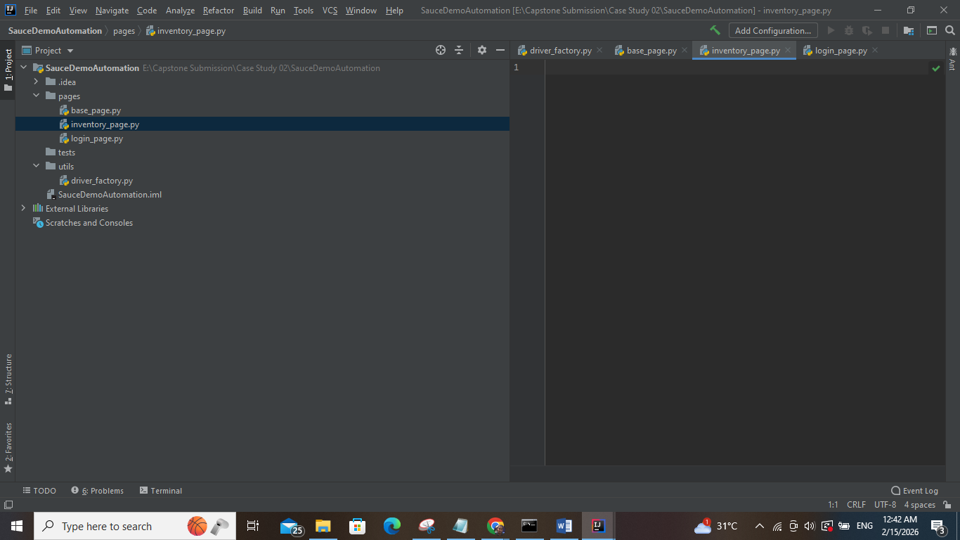

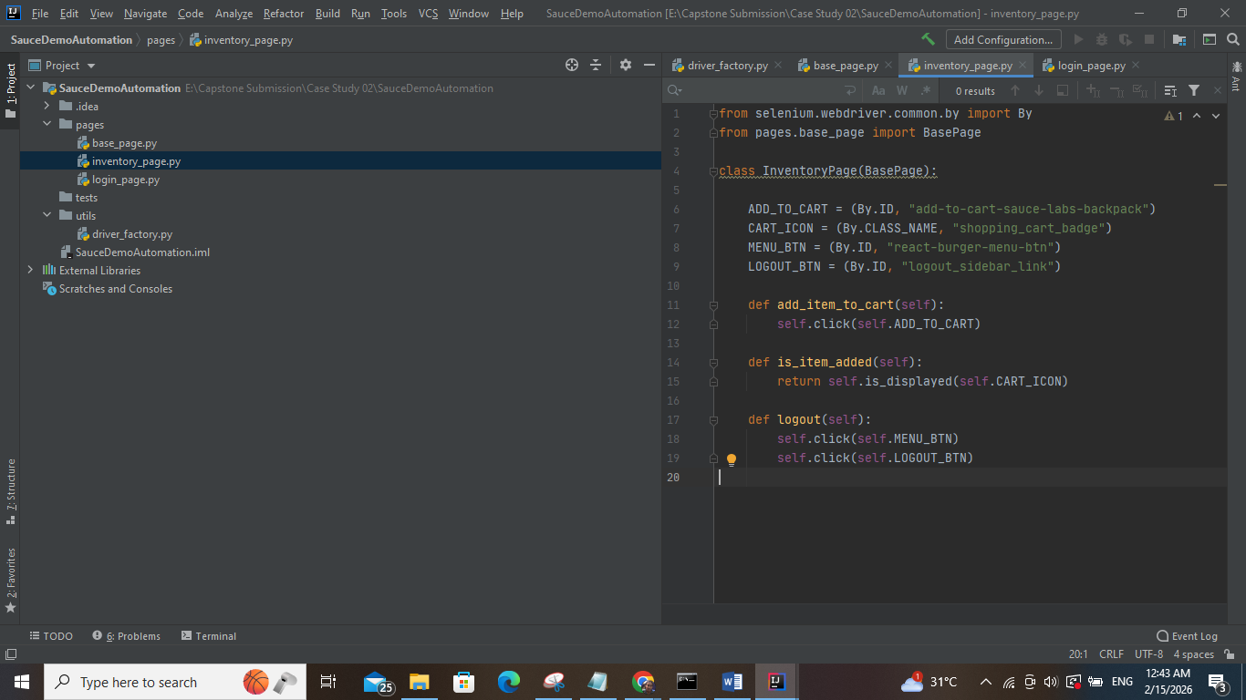

from selenium.webdriver.common.by import By  
from pages.base_page import BasePage  
  
class InventoryPage(BasePage):  
  
 ADD_TO_CART = (By.ID, "add-to-cart-sauce-labs-backpack")  
 CART_ICON = (By.CLASS_NAME, "shopping_cart_badge")  
 MENU_BTN = (By.ID, "react-burger-menu-btn")  
 LOGOUT_BTN = (By.ID, "logout_sidebar_link")  
  
 def add_item_to_cart(self):  
 self.click(self.ADD_TO_CART)  
  
 def is_item_added(self):  
 return self.is_displayed(self.CART_ICON)  
  
 def logout(self):  
 self.click(self.MENU_BTN)  
 self.click(self.LOGOUT_BTN)

### test_saucedemo.py

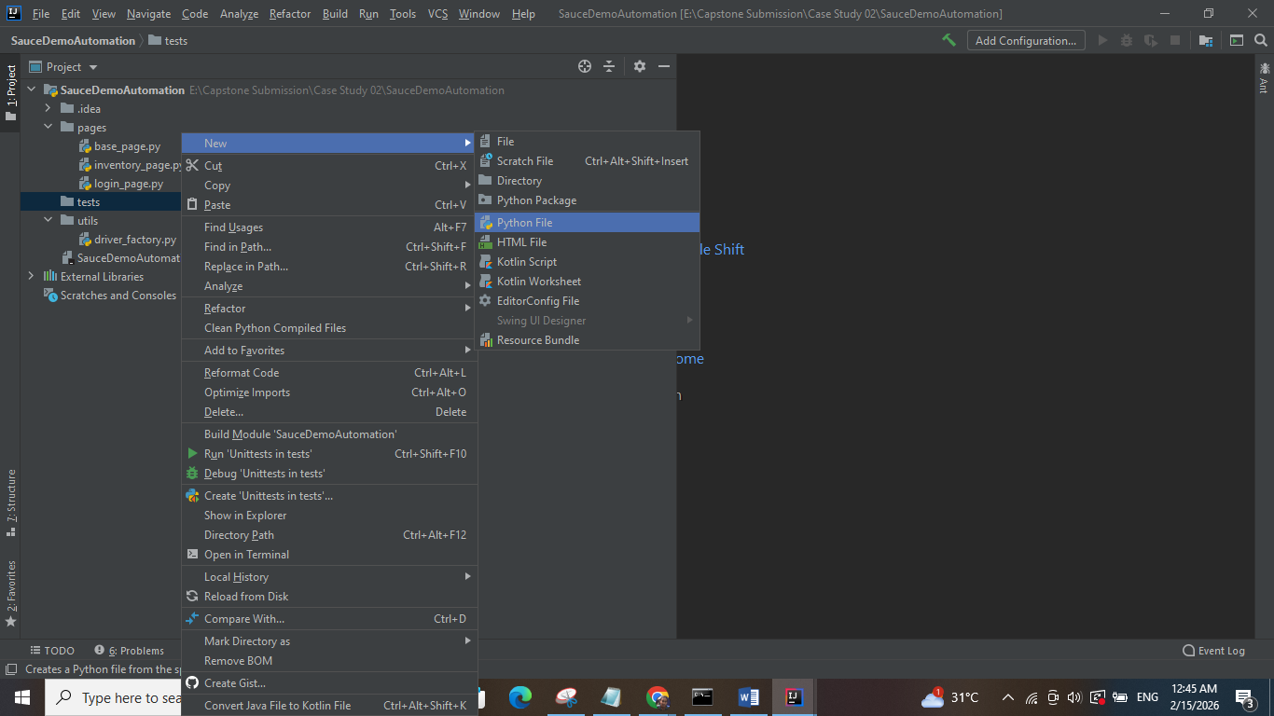

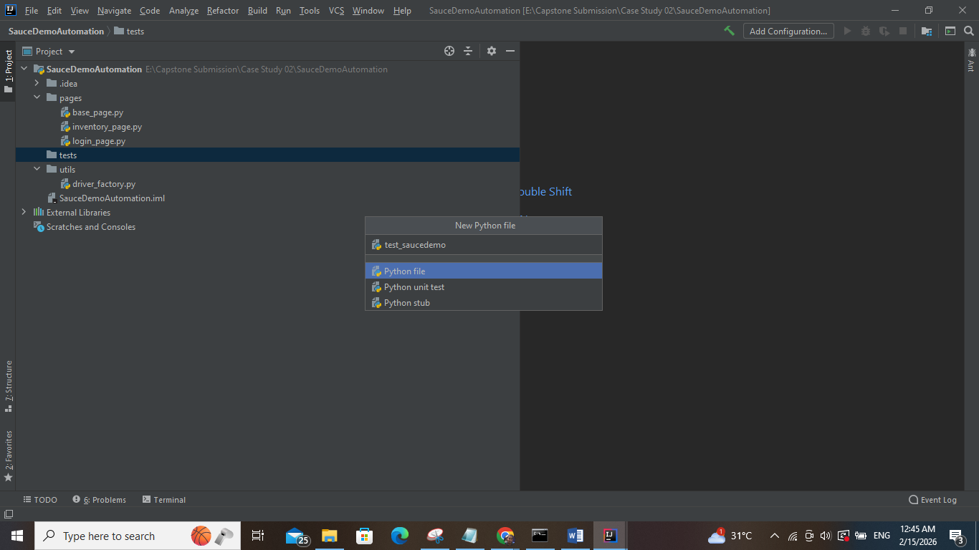

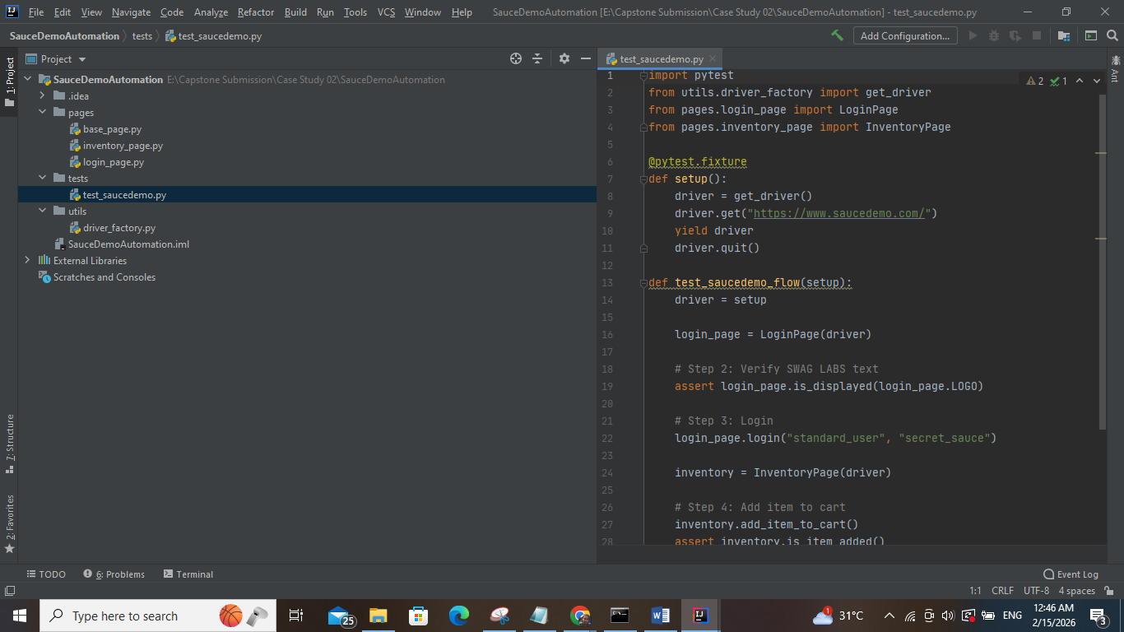

import pytest  
from utils.driver_factory import get_driver  
from pages.login_page import LoginPage  
from pages.inventory_page import InventoryPage  
  
@pytest.fixture  
def setup():  
 driver = get_driver()  
 driver.get("https://www.saucedemo.com/")  
 yield driver  
 driver.quit()  
  
def test_saucedemo_flow(setup):  
 driver = setup  
  
 login_page = LoginPage(driver)  
  
 # Step 2: Verify SWAG LABS text  
 assert login_page.is_displayed(login_page.LOGO)  
  
 # Step 3: Login  
 login_page.login("standard_user", "secret_sauce")  
  
 inventory = InventoryPage(driver)  
  
 # Step 4: Add item to cart  
 inventory.add_item_to_cart()  
 assert inventory.is_item_added()  
  
 # Step 5: Logout  
 inventory.logout()

pytest.ini

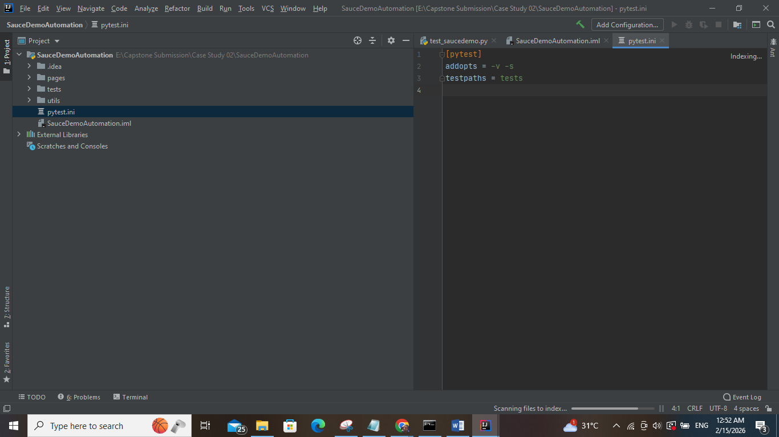

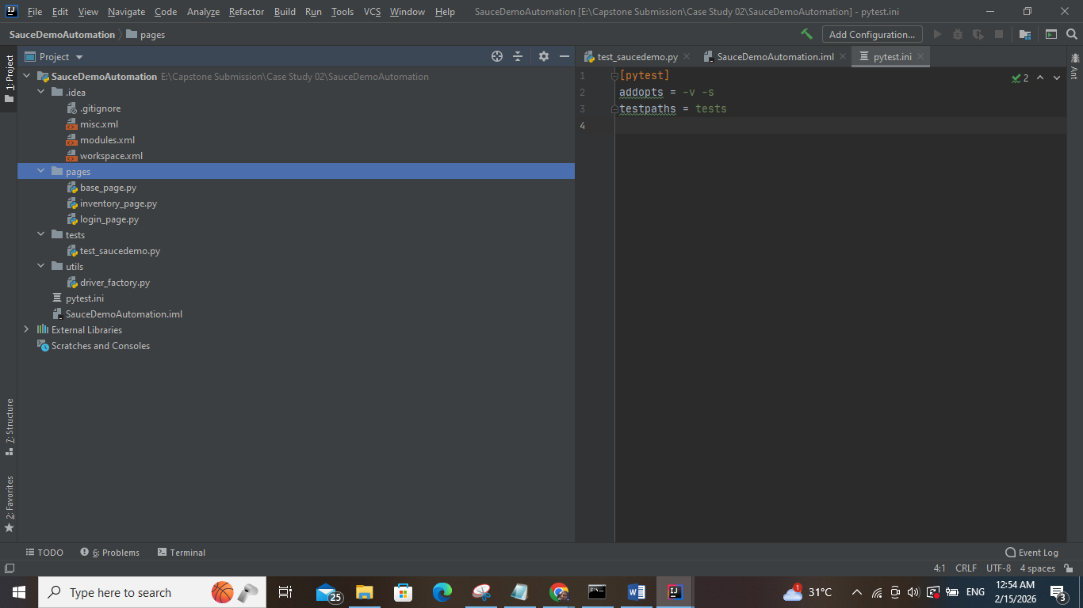

RUN the project

